LONG TEST NO. 2
MATHEMATICS IV

NAME:______________________________________ SCORE:___________
YR.&SEC.:___________________________________ DATE:____________

DIRECTIONS: Write the letter of the best answer on the space provided before the number. Answers must be simplified with the correct unit.

_____ 1. If f(x) = 2x + 3 and g(x) = x² − 3x − 1, then what is f(x) + g(x) ?
A. 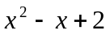 C. 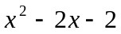
B. 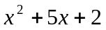 D. 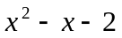

_____ 2. Which of the following relations is a function?
A. { (x, y)/ y ≠ x } C. { (x, y)/ y > x }
B. { ( x, y )/ x = y² } D. { ( x, f(x)) / f(x) = 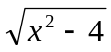 }

_____ 3. What is the range of the function defined by the equation y = x² + 1?
A. y 4 B. y 4 C. y ≥ 1 D. y 1

_____ 4. What are the zeros of the quadratic function y = ( 2x + 6 )( x – 4 ) ?
A. { 3, 4 } B. {−3, 4} C. { 3, − 4} D. { − 3, − 4 }

_____ 5. Given f(x) = 3x + 5 and g(x) = x³ + 2, what is the value of f [ g( 1 ) ] ?
A. 29 B. 26 C. 20 D. 14

_____ 6. If the polynomial 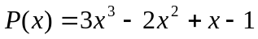 is divided by x – 2 , what is the remainder ?
A. 10 B. 13 C. 15 D. 17
_____ 7. Consider the polynomial function f(x) = 5 – x³. What is the function value at x = − 3?
A. – 4 B. 14 C. 22 D. 32

_____ 8. What is the value of g ( − 2 ), if g(x) = 5x – x ³ .
A. – 16 B. 16 C. – 2 D. – 4

_____ 9. Which of the following relations defines a constant function?
A. y = 5 B. y = x C. x = 5 D. y = x²

_____ 10. What is the domain of the function f(x) = 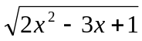 ?
A. 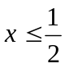 or 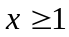 C.  < x < 1
B. 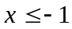 or 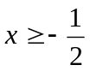 D. x 1
_____ 11. What is the range of the function defined in number 10?
A. 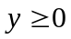 B. y > 0 C. all real numbers D. positive integers

_____ 12. Which of the following graphs shows that for every x, there is one and only one y ?

A. B. C. D.

_____ 13. What is the line of symmetry of the graph of the quadratic function y = x² – 3 x – 10 ?
A. x = B. x = 3 C. x = D. x =

_____ 14. Which one is the vertex of the quadratic function defined in #13?
A. ( 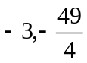) B. ( 3, 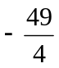) C. ( 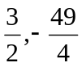) D. ( 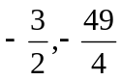).
_____ 15. What is the quotient (Q_{x}) when P(x) = 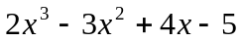 is divided by (x + 1)?
A. 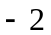x + 5 B. 2x² + 5x C. 2x² + 9 D. 2x² − 5x + 9

_____ 16. If f(x) = 3x – 7 , and 3 ≤ x ≤ 8, what is the range of values of f(x)?
A. 2 ≤ f(x) ≤ 17 B. 2 ≤ f(x) ≤ 16 C. 2 <f(x) ≤ 17 D. 2 < f(x) < 17

_____ 17. What must be the numerical coefficient of x in 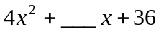 to make it a perfect square
trinomial ?
A. 8 B. 12 C. 20 D. 24

_____ 18. If 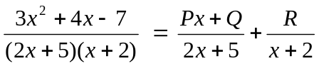, then what are the values of P, Q, and R?

A. P = 3, Q = 4, R = – 3 C. P = 3, Q = 4, R = 3
B. P = – 3, Q = – 4, R = – 3 D. P = – 3, Q = 4, R = – 3

_____ 19. What is the product of (2x + 5) and (3x – 7 ) ?
A. 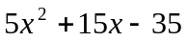 C. 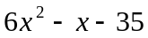
B. 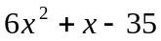 D. 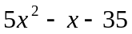

_____ 20. When factored, what is the solution set of 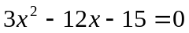?
A. { 1, 5 } B. { 1, 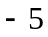} C. { 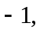 5 } D. { 5 }

_____ 21. What equation is obtained when 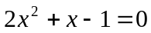 is solved using completing the square?

A. ( x + )= 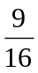 C. ( x )=
B. ( x + )= D. ( x )=

_____ 22. What values of x will make the quadratic equation in #21 true?
A. { } B. { } C. { } D. { }
_____ 23. Which of the following is a factor of the polynomial 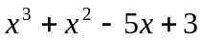 ?
A. x + 1 B. x + 2 C. x + 3 D. x – 2

_____ 24. What is the quotient and the remainder when 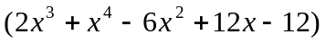 is divided by
( 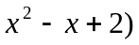?
A. Q(x): 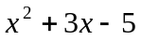; R(x): x – 2 C. Q(x): 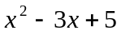; R(x): x – 2
B. Q(x): ; R(x): x + 2 D. Q(x): ; R(x): x + 2

_____ 25. Which of the following defines a linear function?
A. 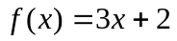 C. g(x)= ( x – 4 )( x – 4)
B. 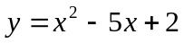 D. 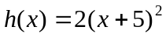
_____ 26. What binomial of lowest degree must be multiplied to 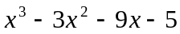 to make it a
polynomial with perfect root?

A. x+5 B. x – 5 C. x – 1 D. x + 1

_____ 27. The graph of the function 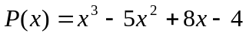 is tangent to the x – axis at what point?
A. ( − 2, 0 ) B. ( 2, 0 ) C. (1, 0 ) D. ( − 1, 0 )

_____ 28. What is the upper bound for the real zeros of the polynomial function 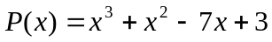
A. 2 B. 3 C. 4 D. 5

_____ 29. Describe the roots of 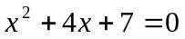.
A. imaginary B. real and equal C. rational and unequal D. irrational

_____ 30. What is the slope of a line parallel to the line whose equation is 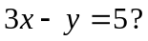
A. 3 B. −3 C. D.
_____ 31. What is the equation of the line described in #30 if it passes through the point ( 2, − 3 ) ?
A. 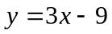 B. 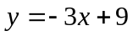 C. 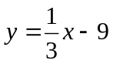 D. 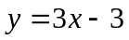
_____ 32. Find two consecutive positive even integers whose sum is 38.
A. 12 and 26 B. 18 and 20 C. 14 and 24 D. 16 and 22

_____ 33. Given that the graph of the polynomial function defined by 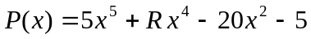
crosses the x – axis between 0 and 1, what is the range of possible values of R ?
A. 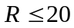 B. 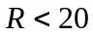 C. 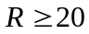 D. 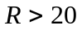

_____ 34. What is the vertex of the parabola defined by the equation 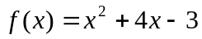?
A. 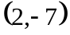 B. 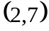 C. 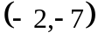 D. 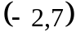

_____ 35. If ( 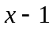) is a factor of the polynomial x² – 2x + 1, which one is the other factor ?
A. (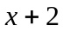) B. (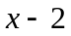) C. (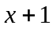) D. ( x – 1 )

_____ 36. If f(x) = 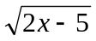, what is its domain ?
A. 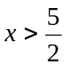 B. 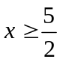 C. 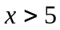 D. 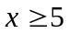
_____ 37. What is the range of the function defined in # 36?
A. 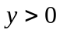 B. C. 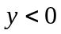 D. 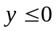

_____ 38. Find the equation of a quadratic function whose zeros are 5 and – 3 .
A. 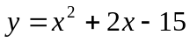 C. 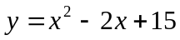
B. 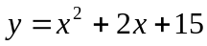 D. 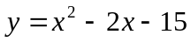
_____ 39. Consider the growth of a single-celled organism. After an hour, when the organism has
gained enough weight, it divides into two. After another hour, each of the two organisms will
divide again into two, and so on. This situation involving growth shows what kind of change?

A. linear B. quadratic C. exponential D. geometric

_____ 40. Using the given situation in number 39, how many organisms would there be after 6 hours?
A. 128 B. 64 C. 32 D. 8

_____ 41. If f(x) = 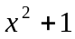 and g(x) = 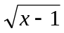, what is the value of ( f o g ) (1)?
A. 0 B. 1 C. – 1 D. 2

_____ 42. Let f 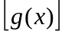= 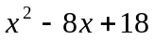, and g(x) = x – 4 , what is f(x) ?
A. 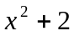 B. 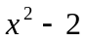 C. 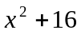 D. 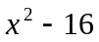

_____ 43. The graph of the function P(x) = 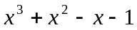 is tangent to the x-axis at what point ? ?
A. ( 1,0 ) B. ( 1, 0 ) C. ( 2, 0 ) D. ( 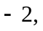0 )

_____ 44. What are the zeros of the polynomial function defined in number 43 ?
A. { 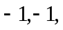1 } C. { 0, 1, 2}
B. { 0, −1, 1} D. { −1, 0, 2 }

_____ 45. What should be the value of k so that ( x + 1) is a factor of 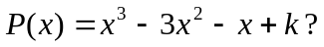?
A. 2 B. 3 C. 4 D. 0

_____ 46. The length of a rectangular field is five more than three times its width. If the width is
( 2x + 5) meters, what is the area of the garden in square meters?
A. 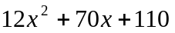 C. 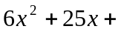 15
B. 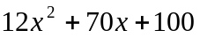 D. 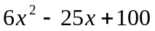

_____ 47. Jane wants to buy a new television worth Php15,000.00 as a gift to her parents. She has
already saved Php10,000.00. How much more does Jane need to buy the television?

A. Php12,000.00 B. Php10,000.00 C. Php8,000.00 D. Php5,000.00

_____ 48. A ball is thrown upward according to the equation f(t) = 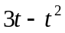, where t is in minutes.
How long does it take the ball to reach the ground ?
A. 1 sec B. 2 sec C. 3 sec D. 4 sec

_____ 49. How high does the ball in number 48 go?
A. 2 units B. 2.25 units C. 3 units D. 3.25 units

_____ 50. The dimensions of a rectangular box are (x + 1) m by (x 1) m by ( x + 2 ) m, respectively.
What is the volume of the box in cubic meters?
A. 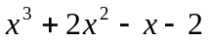 C. 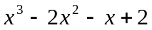
B. 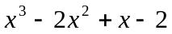 D. 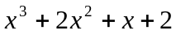

- GOOD LUCK -

